Learn from Others and Be Yourself in Heterogeneous Federated Learning

https://github.com/WenkeHuang/FCCL

Abstract

1. Introduction

2. Related Work

Federated with Data Heterogeneity.

Federated with Model Heterogeneity.

Self-Supervised Learning.

Catastrophic Forgetting.

3. Method

Problem Setup and Notations.

heterogeneous federated learning, data heterogeneity and

model heterogeneity are deﬁned as following:

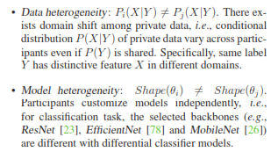

catastrophic problem

|Overview of Framework.

3.1. Federated Cross-Correlation Learning

Motivation of Dimension-Level Operation.

Construction of Cross-Correlation Matrix.

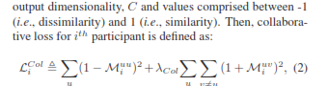

Comparison with Analogous Methods

3.2. Federated Continual Learning

Typical Supervision Loss.

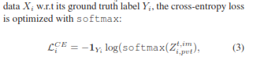

Dual-Domain Knowledge Distillation Loss.

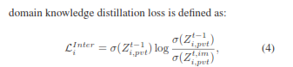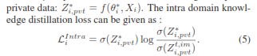

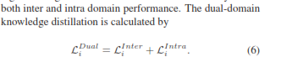

Algorithm 1: The FCCL Framework

3.3. Discussion and Limitation

4. Experiments

Data and Model.

Comparison Methods.

Evaluation Metrics.

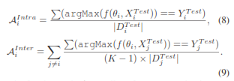

Implementation Details.

4.1. Comparison with State-of-the-Art Methods

Inter Domain Analysis.

Intra Domain Analysis.

Model Homogeneity Analysis.

4.2. Diagnostic Experiments

Federated Cross-Correlation Learning.

Federated Continual Learning.

5. Conclusion

SplitFed: When Federated Learning Meets Split Learning

<https://github.com/chandra2thapa/SplitFed-When-Federated-Learning-Meets-Split-Learning>

<https://paperswithcode.com/paper/splitfed-when-federated-learning-meets-split>

Abstract.

1 Introduction

Computational requirement at the client-side and model privacy during ML training in FL.

Training time overhead in SL.

2 Background and Related Works

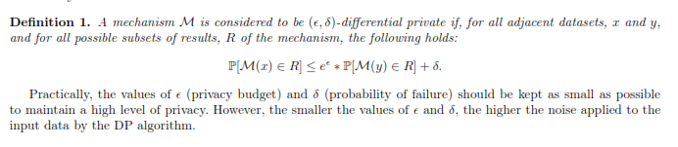

3 The Proposed Framework

3.1 Overall Structure

SFL workflow

Variants of Splitfed Learning.

Based on Server-side Aggregation.

Based on Data Label Sharing.

Algorithm 1: Splitfed Learning (SFL)

3.2 Privacy Protection

Privacy Protection at the Client-side.

Privacy Protection on Fed Server.

Algorithm 2: ClientUpdate

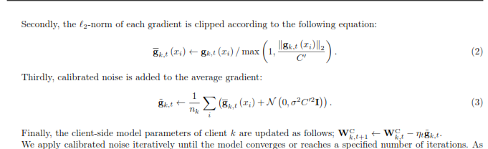

Privacy Protection on Main Server.

Robustness via PixelDP.

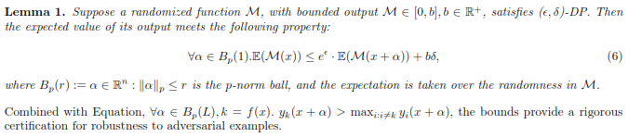

3.3 Total Cost Analysis

4 Experiments

4.1 Performance of FL, SL, SFLV1 and SFLV2

4.2 Effect of Number of Users on the Performance

4.3 SFL with Differential Privacy at the Client-side Model with a PixelDP Noise Layer

5 Conclusion